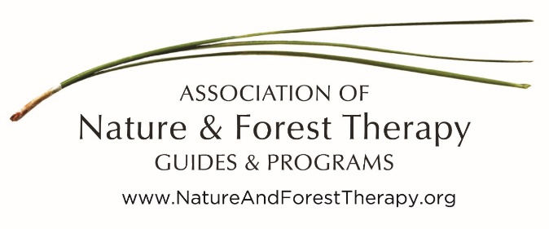

Statement of Intellectual Property for:
A Guide’s Handbook of Forest Therapy
This manual is provided with the following understanding. By using this document, you agree:
- The materials contained in this manual and taught during the Guide Training and Certification Programs are intellectual property (IP) of the Association of Nature and Forest Therapy Guides and Programs (ANFT).
- The ANFT grants permission for you to use them in your capacity as a Certified Forest Therapy Guide and in guiding forest therapy walks.
- You may not give away or use this IP to train others. Sometimes agreements are made allowing use of ANFT IP. Contact nadine@natureandforesttherapy.org with any questions.

Agreed by (Signature):_______________________________________________________

Printed Name:______________________________________________________________

Date:_____________________________________________________________________

