MV Serene

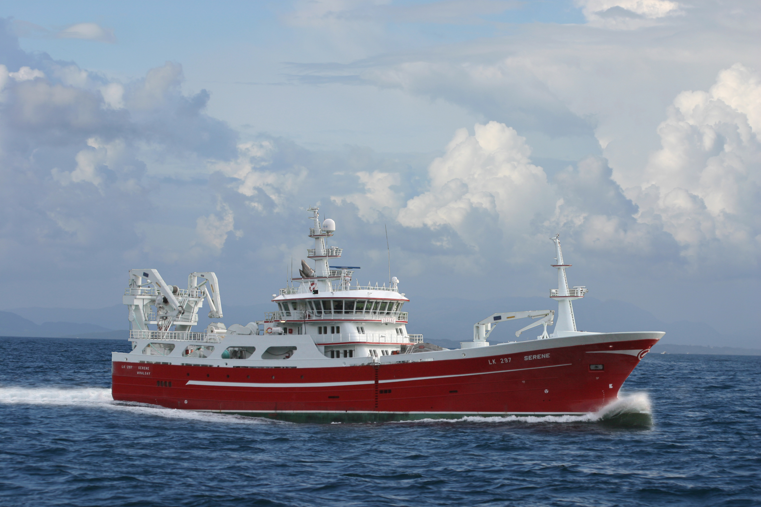

MV Serene – 71.66 m Midwater Trawler.
Delivery in 2009 by West Contractors AS, Ølensvåg, Norway as yard no. 31 to Serene Fishing Company Ltd., Shetland. The design is by Vik & Sandvik AS, Fitjar, Norway. The vessel is built for midwater trawling and carriage of the fish in RSW chilled holds

Principal particulars
Length o.a.: 71,66 m
Length p.p: 62.40 m
Breadth moulded: 15.60 m
Depth to forc. deck: 11.10 m
Speed: Approx. 17,5 knots
Class: DNV +1A1, Fishing vessel, E0, Ice C.

MV Serene
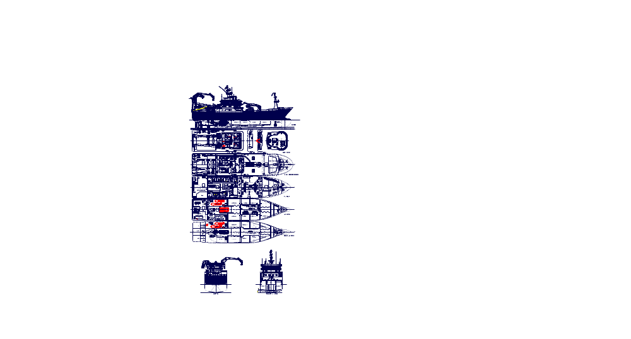

Propulsion system
Main Engine: MAK12M32C
Gear: Scana Volda ACG 950
Propeller system: Scana Volda CP 105/4 blade
Propeller nozzle: NSMB19A

Auxiliary engines
Make: MAK
Main generators: 1x6M20C and 1x8M20C
Harbour generator: CAT C4.4
Emergency generator: CAT C9

Sidethrusters
Make: Brunvoll
Fwd and Aft: FU-63-LTC-1750

Electronical equipment
Radar 1: Furuno FR2127-BB
Radar 2: Furuno FR2137S-BB
Echo sounder 1: Simrad ES60
Echo sounder 2: Furuno FCV30
Echo sounder 3: Furuno FCV1200L28/200
Echo sounder 4: Furuno FSV1200L88/200
Sonar 1: Furuno FSV-30
Sonar 2: Furuno FSV-84
Chart plotter 1: Furuno Navnet 3D Plotter
Chart plotter 2: 2xSodena Mini_Ecdis
Autopilot: Robertson AP-50
Gyrocompass: Robertson GC80
Satelite Compass Furuno SC-110
Log: Furuno CI-68 BB Tidemeter
GPS: 2 x Furuno GP-150 GPS
Trawl Sensor: Simrad FS-70
Catch Sensor: Simrad/Scamnar
GMDSS: Sailor
Navtex: Furuno NX-700B Navtex
Cellphones/fax Ericsson
Sat Phone/fax Iridium/Sailor Fleet Broadb. 500 Sat
VHF: Sailor system
MF/HF Radio: Sailor system
Radio SSB: Sailor 5000 series DSC RT
Intercom: Phonetec
Sat TV: Sea-Tel
Fish Weighing: Marel M2200 Scale
Anemometer: Deif Anemometer

Ship systems
Vessel Management System: Vassnes Automasjon AS
F.O. and L.O. separators: GEA/Westfalia
Air Compressors: 2 x Sperre HL2/90
Oily water separator: JOWA 3 sep OWS
Vent./AC-arrangement: Aeron/Teknotherm
Fans: Aeron
Engine room CO2 plant: Alf Lea & Co
Mob boat: Nor Mar 425 GRP
Liferafts: 2 x delivered by Brude Safety
Ballastmonitoring system: Rolls-Royce UMAS V
Searchlights: Norselight
Fire alarm: Eltec/Tyco
Rudder: Becker SA 2400/243 F.2
Steering Gear: Hatlapa H/DT 160-45
Switchboard: 1x450V – Elpro/1x230V Elpro
RSW plant: MMC Kulde Optiflux
Vacuum pump system: MMC Tendos Vacuum System

Capacities
RSW-holds: approx. 2045m3
Fuel oil: 550 m3
Fresh water: 100 m3
Accomodation: 15 persons

Deck equipment
Deck Crane 1: Karmøy Winch 4T/14,5M
Deck Crane 2: Karmøy Winch 4T/10M
Net Stacker aft: Karmøy Winch 5T/14M
Trawl winches: Karmøy Winch 2 x 95T
Top line winch: Karmøy Winch 80T
Net drums: Karmøy Winch 2 x 43m3/115T
Mid line winch: Karmøy Winch 35T
Tail-end winch: Karmøy Winch 50T
Net sounding winch: Karmøy Winch 7T
Anchor windlass: Karmøy Winch
Aux. Winches: Karmøy Winch 3 x 5T
Fish pump: Karmøy Winch 24”

