Census Outreach Templates:
Field Staff Recruiter

Welcome!

Getting the word out about the Field Staff Recruiter is essential in order for people to use it.

You can use these marketing templates to support your outreach. They include sample flyers, ads, social media templates, stickers (and more!).

Quickly and easily cut and paste these Word templates. Upload your logo, customize your colors and your Census tagline. Be creative and adapt them for the different formats that your reach your constituents and clients.

Remember: try different ways to reach people. Some people will see your flyers, while others will see your emails. In any public marketing campaign, it requires 7-10 exposures for people to take an action, and don’t forget to include translated materials to support your constituents.

Here’s to your successful complete count in the 2020 Census!

Content

- Instructions
- Sample Outbound Text Message
- Social Media Templates
- Email Templates
- Stickers to Promote Text-In
- Sample Flyer and Ad

Instructions

- Use the Samples Provided

Sample Outbound Text Message
Do you have a list of clients who have provided you with permission to contact them? Reach out to your contact list by texting them the provided sample message. (Please contact your Field Staff Recruiter Administrator about how to do this within CommunityConnect Labs’ platform).

Social Media
Use images, videos, and your organization’s Census hashtags. Post regularly but vary the Census content. You can be more creative on social media than other mediums.

For E-mail Lists: Template Email
Customize the subject line and email to be most compelling for your department’s constituents/clients.

For envelopes, letters, and mailers: Stickers and Stamps
Does your department hand out or send out letters or mailers? Use these existing communications to get out the word about the Census!
      - Stamp or add stickers on your print materials, or include a graphic In the print itself if your department can support it
- Stickers: You can use these templates for stickers and stamps on mailers and packages.
- Square stickers: Avery Template 60504 – UltraDuty GHS Labels, 4" x 4", 4 per Sheet, White.
- Round stickers: Avery Template 22830 – Print-to-the-Edge Round Labels, 2-1/2" diameter, 9 per Sheet, White

- Customize Your Marketing

- Enter your dedicated phone number and start word
- Look up enumerator pay rates in your area at https://2020census.gov/en/jobs/pay-and-locations.html
- Insert your logo: right click on “Add Your Logo”, select “Change Picture”, then navigate to the logo location on your computer. Resize if necessary.
- Change text color, fonts and sizes if desired.

- Add images or videos

- Research shows that people are much more likely to pay attention to communications that have a photo or a video.
- Use photos and videos of your community
- Use free Census galleries such as http://www.creativesforthecount.org

Hi, it’s [ORG]. Did you know the Census is hiring part-time Census takers for up to $[ENTER AMOUNT]/hour in your community? Type S to find out if you’re eligible and how to apply.

Msg&DataRatesMayApply

S to Start
N No thanks

Sample Outbound Text Message

Social Media Templates
Job Alert! Enumerator positions with the U.S. Census Bureau. Part-time, flexible, pays [ENTER AMOUNT]/hour in [ENTER YOUR COUNTY]. Text [INSERT START WORD] to [INSERT #] and learn how to apply. #CensusJobs

The U.S. Census Bureau is hiring part-time field staff to help ensure [ENTER YOUR COUNTY, CITY, or STATE] is fully counted in the #2020Census. Text [INSERT START WORD] to [INSERT #] and learn how to apply. #CensusJobs

Make Your Social Media Posts Visual

Easily create more visual posts by selecting a Census related photo and placing a headline, the text-in call to action, and your logo over it. The more emotional the picture, the more compelling your post will be. Include any additional information and your Census hashtags in the caption!

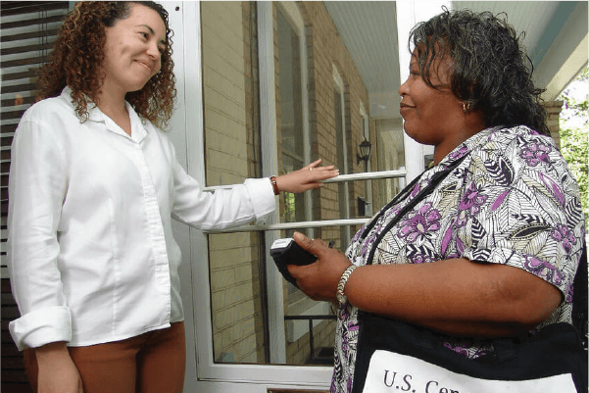
FOR THE CENSUS

WORK PART-TIME

Text [INSERT START WORD to [#]
And Learn How to Apply

WORK PART-TIME
FOR THE CENSUS

Text [INSERT START WORD to [#]

And Learn How to Apply

Email Template
[Subject line: “Work Part-Time for the Census: Earn Up to $[XX]/Hour, flexible schedule”]
[Alternate Subject line: “Earn Up to $[XX] Per Hour as a Part-Time Census Taker”]

Dear [First name],

The Census Bureau is hiring part-time Census takers to work from April to July 2020, with paid training starting in March. Census taker jobs are well-paid positions with flexible hours and few work experience requirements. The job pays up to $[ENTER AMOUNT]/hour in [ENTER YOUR COUNTY], and applicants 18 or older without a serious criminal history are likely to qualify.

Ensuring that your community gets counted in the 2020 Census is the best way you can give back while earning money. Each person counted helps secure money for schools, roads, and hospitals in your neighborhood.

To find out if you qualify and to get started with the application:

Text [INSERT START WORD] to [INSERT #]

Text in if you’re interested in the position, or forward this email to someone who might be.

Here’s to a complete count!
[Your Organization]

Make $X/hr Working
Part-Time for the Census
Text [START WORD] to

[ENTER #]

and Learn How to Apply

Make $X/hr Working
Part-Time for the Census

Text [START WORD] to

[ENTER #]

and Learn How to Apply

Make $X/hr Working
Part-Time for the Census

Text [START WORD] to

[ENTER #]

and Learn How to Apply

Make $X/hr Working
Part-Time for the Census

Text [START WORD] to

[ENTER #]

and Learn How to Apply

Make $X/hr Working
Part-Time for the Census

Text [START WORD] to

[ENTER #]

And Learn How to Apply
Make $X/hr Working
Part-Time for the Census

Text [START WORD] to

[ENTER #]

And Learn How to Apply

Make $X/hr Working
Part-Time for the Census

Text [START WORD] to

[ENTER #]

And Learn How to Apply

Make $X/hr Working
Part-Time for the Census

Text [START WORD] to

[ENTER #]

And Learn How to Apply

Make $X/hr Working
Part-Time for the Census
Text [START WORD] to

[ENTER #] and

Learn How to Apply
Make $X/hr Working

Part-Time for the Census

Text [START WORD] to

[ENTER #] and

Learn How to Apply

Make $X/hr Working

Part-Time for the Census

Text [START WORD] to

[ENTER #] and

Learn How to Apply
Make $X/hr Working

Part-Time for the Census

Text [START WORD] to

[ENTER #] and

Learn How to Apply

Make $X/hr Working

Part-Time for the Census

Text [START WORD] to

[ENTER #] and

Learn How to Apply
Make $X/hr Working

Part-Time for the Census

[ENTER #] and

Learn How to Apply
Text [START WORD] to

Make $X/hr Working

Part-Time for the Census

Text [START WORD] to

[ENTER #] and

Learn How to Apply

Make $X/hr Working

Part-Time for the Census

Text [START WORD] to

[ENTER #] and

Learn How to Apply
Make $X/hr Working

Part-Time for the Census

[ENTER #] and

Learn How to Apply
Text [START WORD] to

Make $X/hr Working

Part-Time for the Census

Text [START WORD] to

[ENTER #] and

Learn How to Apply
Make $X/hr Working

Part-Time for the Census

Text [START WORD] to

[ENTER #] and

Learn How to Apply

Make $X/hr Working

Part-Time for the Census

Text [START WORD] to

[ENTER #] and

Learn How to Apply
Make $X/hr Working

Part-Time for the Census

Text [START WORD] to

[ENTER #] and

Learn How to Apply
Make $X/hr Working

Part-Time for the Census

Text [START WORD] to

[ENTER #] and

Learn How to Apply

Make $X/hr Working

Part-Time for the Census

Text [START WORD] to

[ENTER #] and

Learn How to Apply
Make $X/hr Working

Part-Time for the Census

Text [START WORD] to

[ENTER #] and

Learn How to Apply
Make $X/hr Working

Part-Time for the Census

Text [START WORD] to

[ENTER #] and

Learn How to Apply

Make $X/hr Working

Part-Time for the Census

Text [START WORD] to

[ENTER #] and

Learn How to Apply
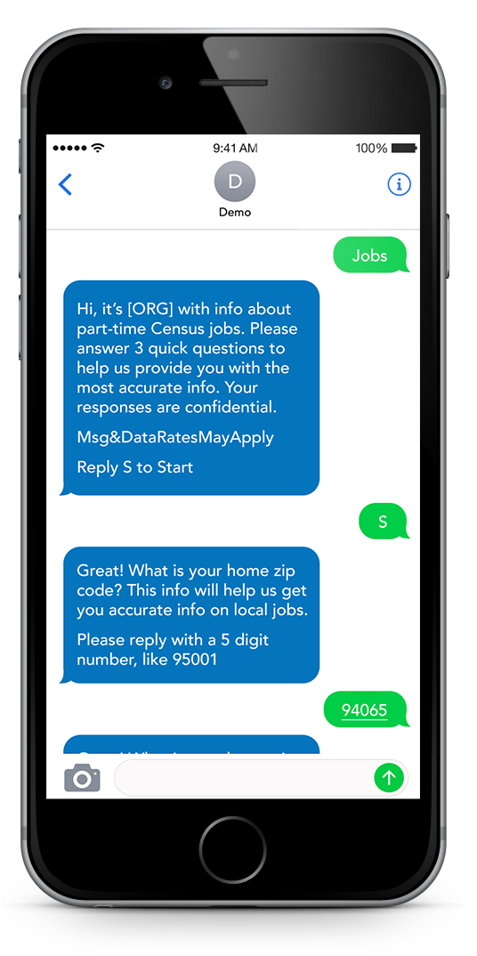
Text [ENTER START WORD] to [ENTER #]
and Learn How to Apply
WORK PART-TIME
FOR THE CENSUS
[ENTER #] And Get Answers

Text Your Questions to

- Earn up to $[Enter Amount]/hour
- Choose your own hours:
Evening & weekend shifts available
- Part-time (May – July 2020)
- Perfect for busy schedules

All candidates must be U.S. Citizens and 18 years of age or older

*To stop receiving text messages from this number at any time text “EXIT” or “STOP”
*Standard message and data rates may apply

See: http://bit.ly/ccl-privacy for Privacy Policy
See: http://bit.ly/ccl-service for Terms of Service
WORK PART-TIME FOR THE CENSUS

- Earn $XX an hour
- Choose your own hours
- Perfect for busy schedules
Text [START WORD] to [ENTER #] and Learn How to Apply

Ensure You’re Counted in the 2020 Census to Secure Funding for Your Community

