Census Outreach Templates:
HelpDesk

Welcome!

Getting the word out about the HelpDesk is essential in order for people to use it.

You can use these marketing templates to support your outreach. They include sample flyers, ads, social media templates, stickers (and more!).

Quickly and easily cut and paste these Word templates. Upload your logo, customize your colors and your Census tagline. Be creative and adapt them for the different formats that your reach your constituents and clients.

Remember: try different ways to reach people. Some people will see your flyers, while others will see your emails. In any public marketing campaign, it requires 7-10 exposures for people to take an action, and don’t forget to include translated materials to support your constituents.

Here’s to your successful complete count in the 2020 Census!

Content

- Instructions
- Sample Outbound Text Message
- Social Media Templates
- Email Templates
- Stickers to Promote Text-In
- Sample Flyer and Ad

Instructions

- Use the Samples Provided

Sample Outbound Text Message
Do you have a list of clients who have provided you with permission to contact them? Reach out to your contact list by texting them the provided sample message. (Please contact your HelpDesk Administrator about how to do this within CommunityConnect Labs’ platform).

Social Media
Use images, videos, and your organization’s Census hashtags. Post regularly but vary the Census content. You can be more creative on social media than other mediums.

For E-mail Lists: Template Email
Customize the subject line and email to be most compelling for your department’s constituents/clients.

For envelopes, letters, and mailers: Stickers and Stamps
Does your department hand out or send out letters or mailers? Use these existing communications to get out the word about the Census!

- Stamp or add stickers on your print materials, or include a graphic In the print itself if your department can support it
- Stickers: You can use these templates for stickers and stamps on mailers and packages.
- Square stickers: Avery Template 60504 – UltraDuty GHS Labels, 4" x 4", 4 per Sheet, White.
- Round stickers: Avery Template 22830 – Print-to-the-Edge Round Labels, 2-1/2" diameter, 9 per Sheet, White

- Customize Your Marketing

- Enter your dedicated phone number and start word
- Insert your logo: right click on “Add Your Logo”, select “Change Picture”, then navigate to the logo location on your computer. Resize if necessary.
- Change text color, fonts and sizes if desired.

- Add images or videos

- Research shows that people are much more likely to pay attention to communications that have a photo or a video.
- Use photos and videos of your community
- Use free Census galleries such as http://www.creativesforthecount.org
Hi, it’s [ORG]. We want to make sure you’re counted in the 2020 Census to secure funding for your community. Do you have any questions about completing the Census? Text questions to this number at any time and get answers.

Msg&DataRatesMayApply

Sample Outbound Text Message

Social Media Templates
Need help completing the Census? Have any questions? Text questions to [INSERT #] and get answers #2020Census

The Census will be happening this month! Check your mailboxes for the survey. Have questions about the Census? Text questions to [INSERT #] and get help #2020Census

Make Your Social Media Posts Visual

Easily create more visual posts by selecting a Census related photo and placing a headline, the text-in call to action, and your logo over it. The more emotional the picture, the more compelling your post will be. Include any additional information and your Census hashtags in the caption!

HAVE QUESTIONS
ABOUT THE CENSUS?
Text questions to [ENTER #]
And Get Answers

HAVE QUESTIONS
ABOUT THE CENSUS?

Text questions to [ENTER #]

And Get Answers

Email Template
[Subject line: What Is the Census and Do I Need to Participate?”]

Dear [First name],

Every 10 years, we get one chance to collect accurate Census data to help make sure we have the funding for our schools, roads, hospitals, and more. Everyone’s participation is critical to ensure a complete count, but many people don’t even know where to start.

Do you have questions about the Census? Ask the Q&A HelpDesk — it’s a text messaging question and answer system that can help answer any of your Census questions:

- When is the Census?
- How do I fill it out?
- Is the Census available online?
- What’s the difference between race and ethnicity?
- . . . and many more

Have a question? Text your question to [INSERT #]

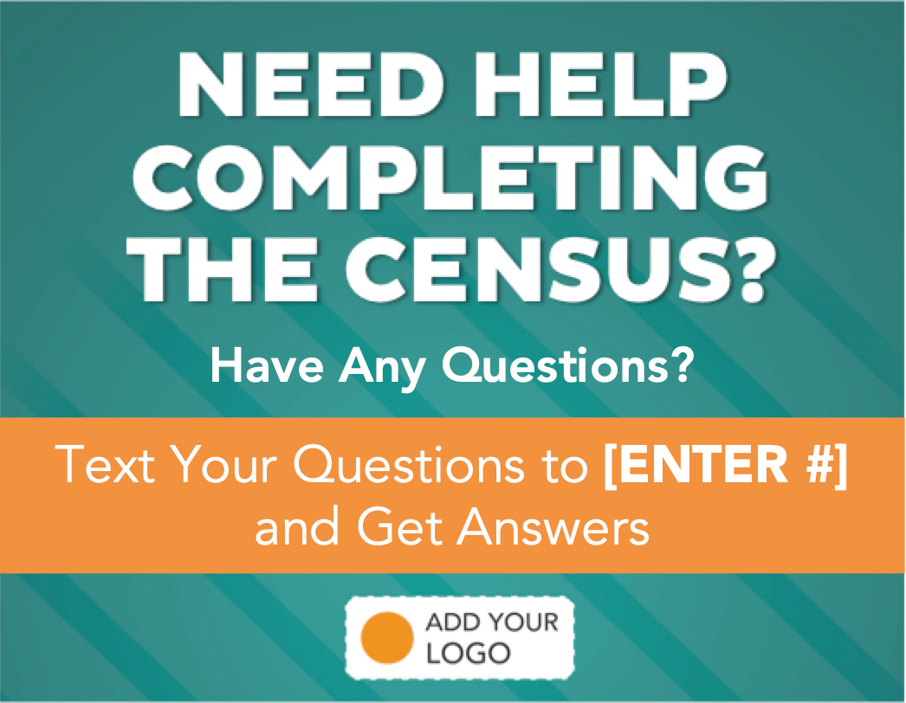

Thank you for your participation!
[Your Organization]

Have Questions About the Census?

Text questions to [ENTER #]

and Get Answers

Have Questions About the Census?

Text questions to [ENTER #]

and Get Answers

Have Questions About the Census?

Text questions to [ENTER #]

and Get Answers

Have Questions About the Census?

Text questions to [ENTER #]

and Get Answers

Have Questions About the Census?
Text questions to [ENTER #]

and Get Answers

Have Questions About the Census?
Text questions to [ENTER #]

and Get Answers

Have Questions About the Census?
Text questions to [ENTER #]

and Get Answers

Have Questions About the Census?
Text questions to [ENTER #]

and Get Answers

Have Questions

about the
Census?
Text questions to [ENTER #]

And Get Answers

Have Questions

about the
Census?
Text questions to [ENTER #]

And Get Answers

Have Questions

about the
Census?
Text questions to [ENTER #]

And Get Answers
And Get Answers

Have Questions

about the
Census?
Text questions to [ENTER #]

And Get Answers

Have Questions

about the
Census?
Text questions to [ENTER #]

And Get Answers

Have Questions

about the
Census?
Text questions to [ENTER #]

And Get Answers

Have Questions

about the
Census?
Text questions to [ENTER #]

And Get Answers

Have Questions

about the
Census?
Text questions to [ENTER #]

And Get Answers

Have Questions

about the
Census?
Text questions to [ENTER #]

And Get Answers

Have Questions

about the
Census?
Text questions to [ENTER #]

And Get Answers

Have Questions

about the
Census?
Text questions to [ENTER #]

And Get Answers

Have Questions

about the
Census?
Text questions to [ENTER #]

And Get Answers

Have Questions

about the
Census?
Text questions to [ENTER #]

And Get Answers

Have Questions

about the
Census?
Text questions to [ENTER #]

And Get Answers

Have Questions

about the
Census?
Text questions to [ENTER #]

And Get Answers

Have Questions

about the
Census?
Text questions to [ENTER #]

And Get Answers

Have Questions

about the
Census?
Text questions to [ENTER #]

And Get Answers

Have Questions

about the
Census?
Text questions to [ENTER #]

And Get Answers

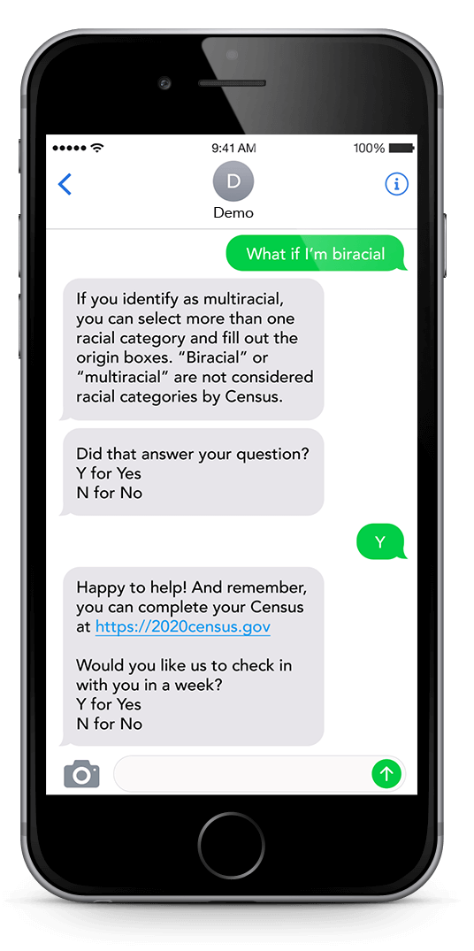
[ENTER #] And Get Answers

Text Your Questions to

Help Your Schools and Hospitals Get Funding They Need

NEED HELP COMPLETING THE CENSUS? HAVE ANY QUESTIONS?
*To stop receiving text messages from this number at any time text “EXIT” or “STOP”
*Standard message and data rates may apply
See: http://bit.ly/ccl-privacy for Privacy Policy
See: http://bit.ly/ccl-service for Terms of Service

[ENTER #] And Get Answers

Text Your Questions to

NEED HELP COMPLETING THE CENSUS?

Have Any Questions?

Text Your Questions to [ENTER #]
and Get Answers

