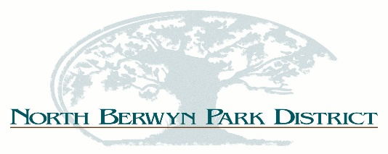
BOARD OF COMMISSIONERS
REGULAR MEETING MINUTES
Thursday, April 12, 2018
5:30 p.m.

- Call To Order
- Pledge of Allegiance
- Roll Call – - President Mackin called the meeting to order at 5:30 pm; Upon the roll call all commissioners were present, also in attendance was Director Vallez.
- Corrections/Additions/Approval of Agenda: . Commissioner Hajer-O’Connor motioned to approve agenda, 2nd by Commissioner Vazquez. All in favor, motion passed.5/0.
- Approval of Minutes
  - REGULAR MEETING – March 8, 2018, Sladek, 2nd by Vazquez, 5/0, motion passed.
  - SPECIAL MEETING – Deferred to May Meeting
- Public Comment – None
- Treasurers Report –
- Cash Disbursements – Commissioner Sladek motioned to approve, 2nd by Hajer-O’Connor, 5/0, motion passed.
- Financial Report – Commissioner Kearns motioned to approve, 2nd by Vazquez, motion passed, 5/0.
- Staff Reports:
- Executive Director Report:
  - Update on Grants, cycle has not opened yet.
  - Master Plan update, still looking for a reasonably priced update plan.
  - Republic Bank: meeting with Republic about continued relations.
  - Fiesta 2018: Continuing with plans for a two day event.
  - 5K Run: was approved by the City of Berwyn.
  - Arts Center: revising final plans should have documents at next meeting.
  - Easter Events: went well even with the rain issue.
  - JCV Vacation: April 21 – May 1.
  - Special Events List.
- WSSRA:
- Unfinished Business:
- Master Plan/Strategic Plan – I will be searching for more pricing.
- OSLAD Grant/PARC Grant: Update
- VFW: Contract was signed and in the “Due Diligence” period.
- Fiesta 2018/5K Run: Director Report.
- NRPA: Conference Expenses for review.
- Maintenance Garage Sale: Update
- Jefferson Field: Update
- New Business:
  - Capital Projects: Public Relations Campaign
- Public Comment: None
- Executive Session:
- Adjournment: Motion by Kearns, 2nd by Vazquez motion passed,5/0. 6:34 pm

